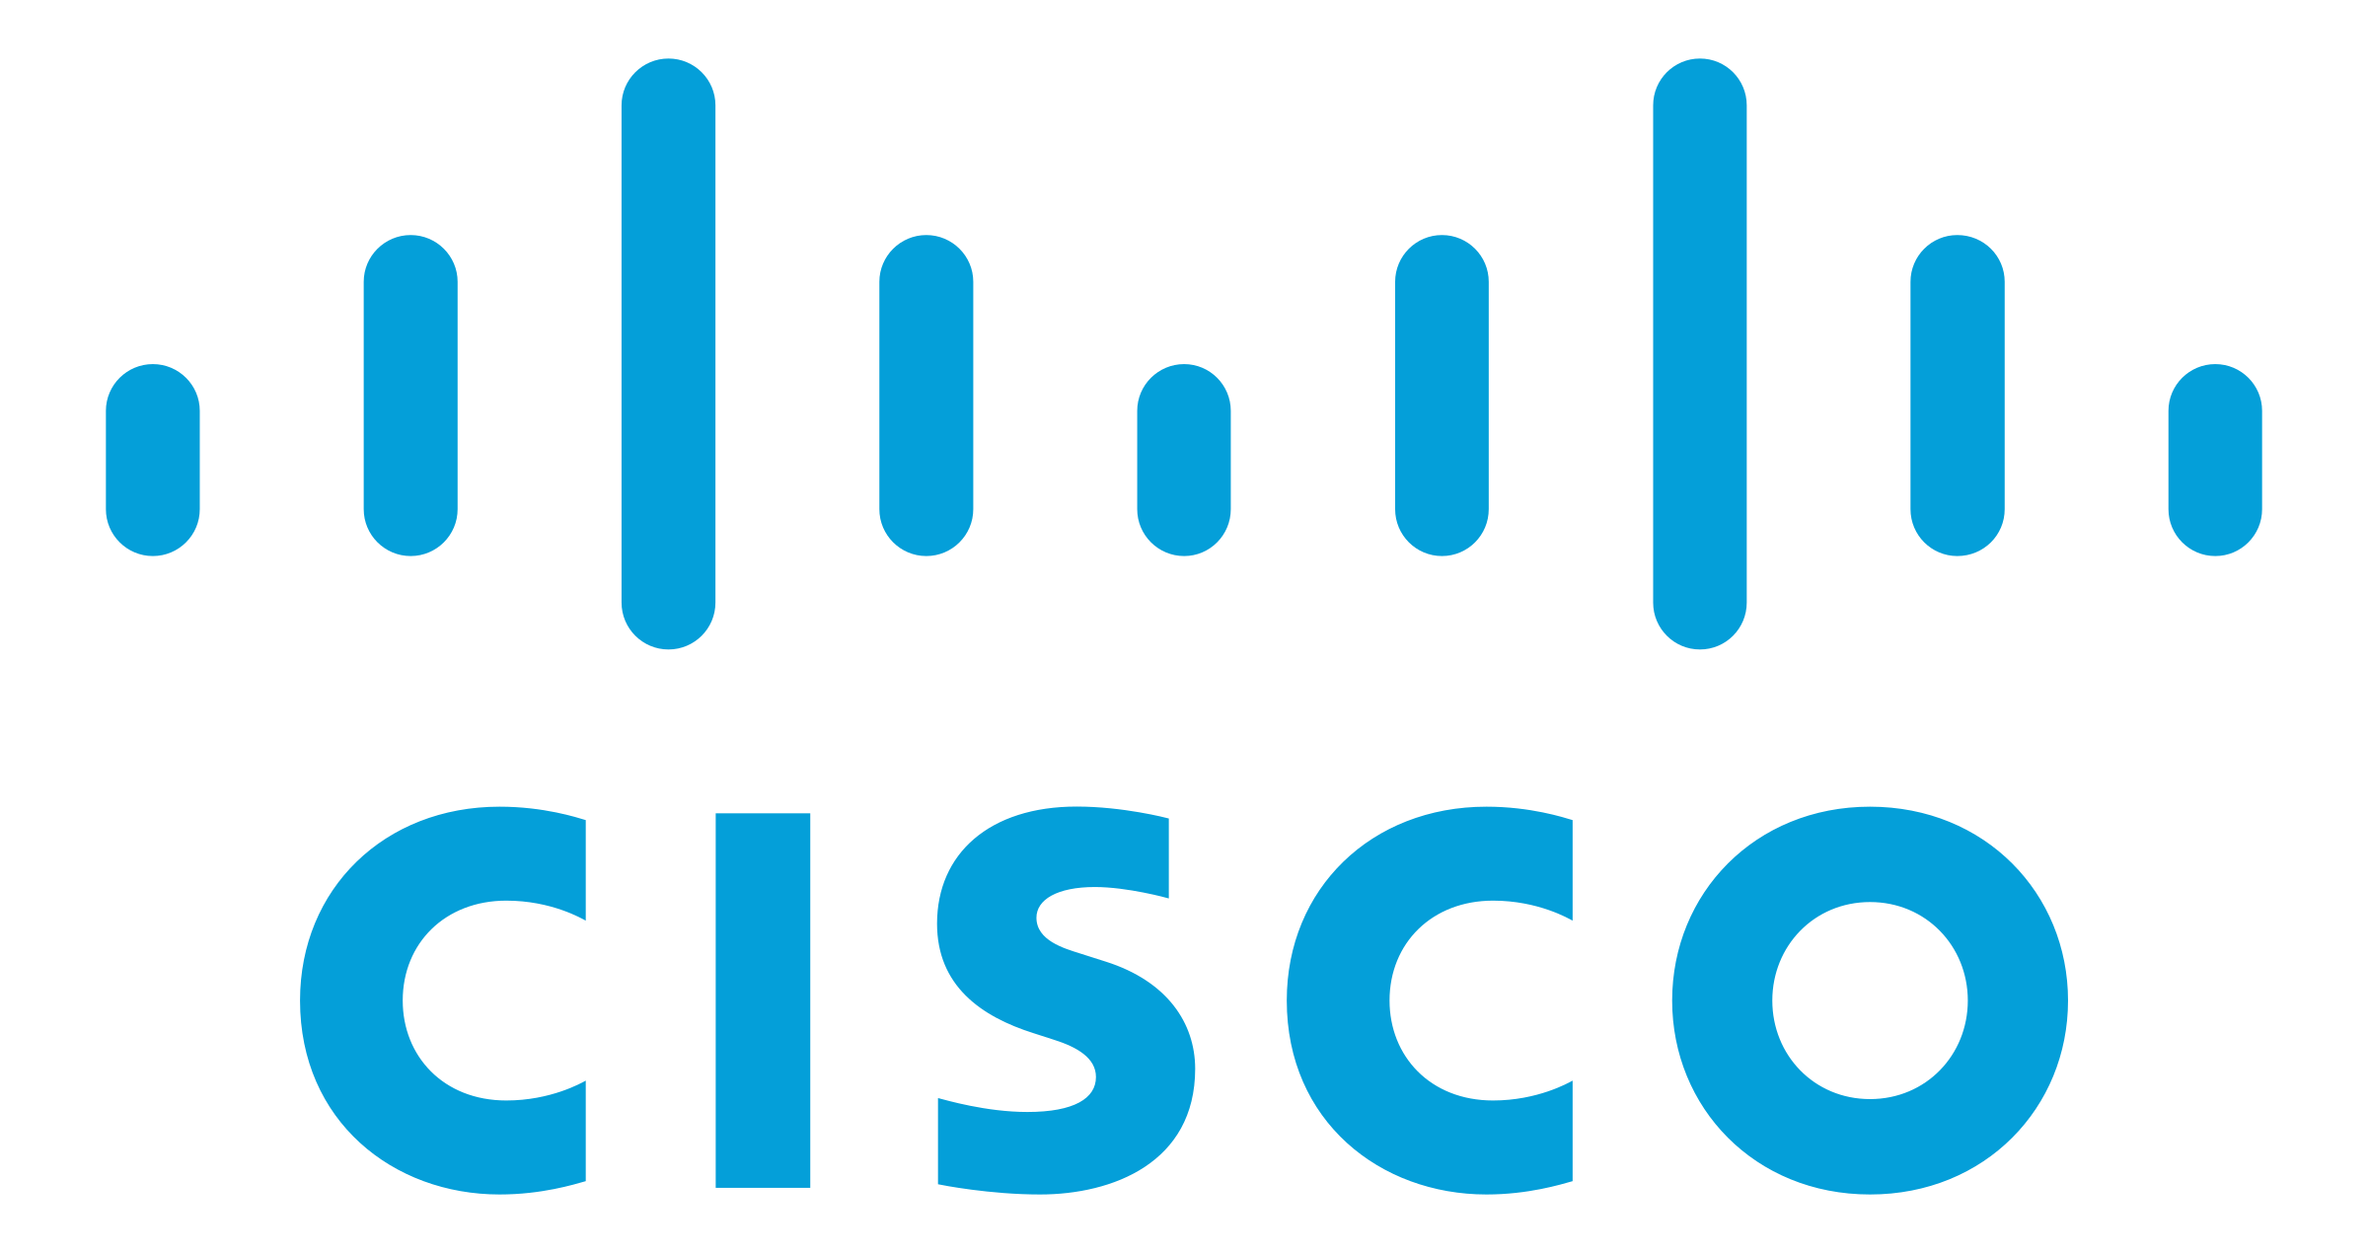

**VRF Implementation Documentation**

Ryan Chen

6/6/2024

**Purpose:**

The primary purpose of this lab is to familiarize ourselves with VRF routing concepts as well as implementation. To do so, we utilized the GNS3 network virtualization software, which provides enterprise-level software for companies to create fully virtualized simulations or infrastructure. Along the way, we learned commands on how to implement VRF on Cisco devices, as well as VRF configuration of other protocols such as OSPF. This lab was also a basic refresher on fundamental concepts such as subnetting, OSPF setup, and other.

**Background Information:**

Virtual Route Forwarding, or VRF for short is a type of networking technology that utilizes virtualization in order to optimize network efficiency by reducing the number of network devices needed. In a traditional network topology, multiple routers must exist for an overlapping IP address scheme to be used. Due to the nature of routing tables, overlapping IP addresses would resulting in unresolvable errors. Since routers assume that their tables are completely non-overlapping, having an overlapping range would result in incorrect packets being forwarded, or more likely no packets being forwarded at all.

VRF fixes this by logically segmenting the router into multiple different “virtual” routers. Each of these routers has an independent routing table, allowing multiple overlapping subnets to exist on the same router, bypassing traditional limitations. There exist numerous use cases for this technology, as it brings benefits such as security, efficiency, and ease of configuration.

For one, VRF introduces greater network isolation. Segmenting the router into numerous, separate virtual routers allows hypothetical customers to be fully separate from each other. This means malicious activity/traffic on one virtual router would not have a significant effect on other customers. Using the example of an ISP company, configuring VRF’s brings near full isolation between customers. Customers can use the same subnet ranges internally, however, still function as if they were running on completely different routers.

Continuing the example of an ISP company, configuring VRF’s simplifies network topology and efficiency. Combining the traditional task of numerous routers into one router allows ISP companies to scale more easily, as well as making debugging and physical network topology simpler. Having less network devices reduces the need for troubleshooting if an issue occurs.

Despite this, there are also tradeoffs that must be considered before implementing VRF. Having multiple virtual routers exist on a single router leads to a more concentrated single point of failure. If the single router fails, multiple customers may be immediately affected. This would be mitigated in a traditional topology, where one customer usually corresponds to one router. However, this can be alleviated by introducing standby routers or other failover technologies.

There are two primary types of VRF: normal VRF and VRF-lite. In this lab, we utilized VRF-lite. The only significant difference between the two types is that normal VRF requires configuration of MPBGP and MPLS, making it more complicated and used for a different purpose. Normal VRF is more typically used in production or business environments, as it allows for more scalability. On the other hand, VRF-lite is used by individuals or businesses for test environments.

**Lab Summary:**

Within this lab, we utilized GNS3 combined with VirtualBox in order to simulate a real routing topology. We segmented our topology into two different VRF’s, with left and right sharing the same subnet but different logical routing. This means that PC1 and PC3 can ping each other, but not to P2 or P4, despite them being on the same subnet.

GNS3 was the primary network virtualization software that allowed us to simulate real C7200 Cisco routers. With compatibility between GNS3 and common desktop virtualization software, we were able to create four virtual machines (simulating customers) and then import them into GNS3.

Generally, the topology reflects a hypothetical situation where an ISP might use VRF’s in order to logically segment two customers while reducing topology complexity. Each side of the network is separate, and functions on its own with minimal disruption.

**Network Diagram and IP Table:**

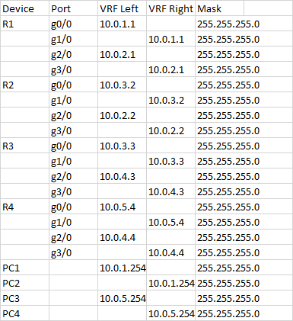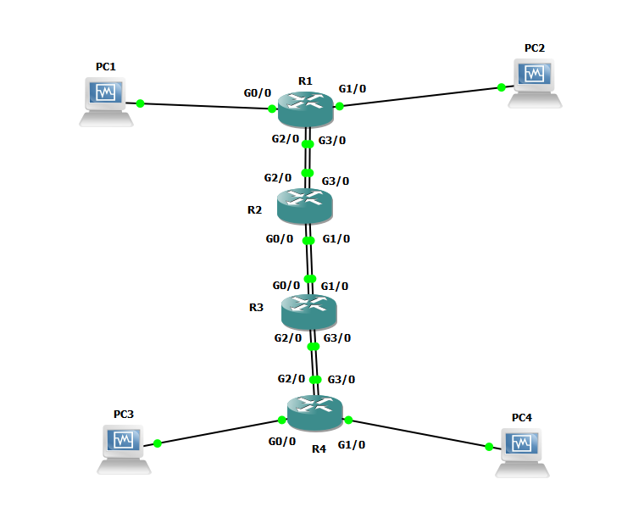**Configurations:**

**GNS3 C7200 Setup:**

1. Navigate to the following link and download an appropriate version of the Cisco C7200 router: <https://github.com/hegdepavankumar/Cisco-Images-for-GNS3-and-EVE-NG?tab=readme-ov-filehttps://gns3.com/cisco-7200>
2. Ensure that the file downloaded matches the known checksum for the file. This is to prevent installing any potential malicious software. You can find the known checksum of the C7200 router in the given GNS3 configuration file. Then, check that the MD5 checksum matches.

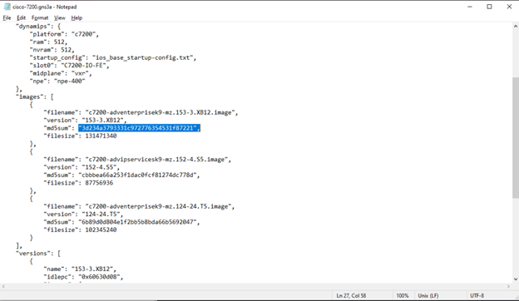

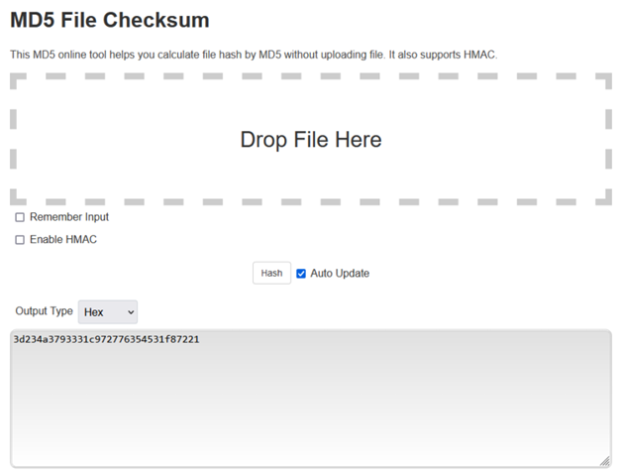

1. If the checksum matches, you can now proceed to installing the router image using GNS3. Select the appropriate version name, and GNS3 will check if the router image is correct. If it is fine, it will display that it is ready to install.

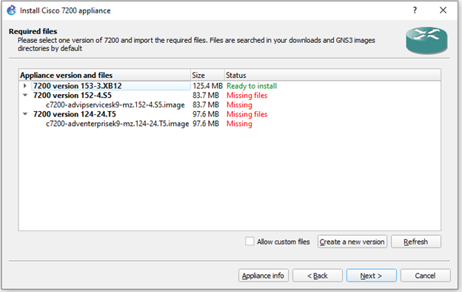

1. Continue to installation, and GNS3 will install the template for the C7200 router. The template will appear in the GNS3 router devices category, and can be dragged into the network topology to be used.

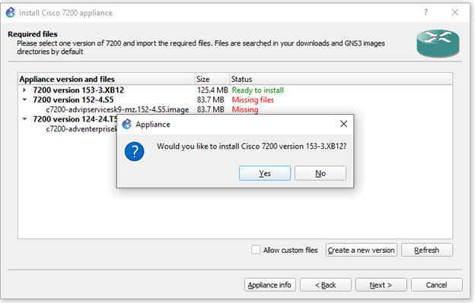

1. Ensure that the router is functioning by starting it. It can be started by right clicking and pressing “Start”. To enter into the virtualized Cisco CLI, press the Console button.

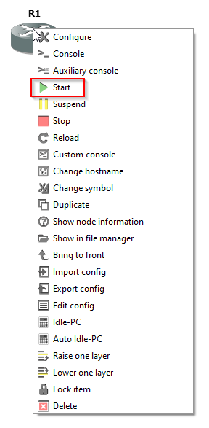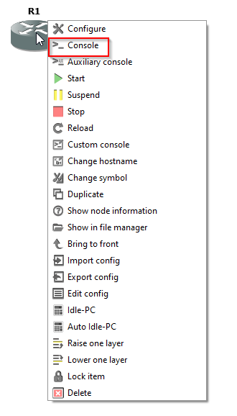

1. Ensure that the device is correctly virtualized by checking the CLI startup log messages.

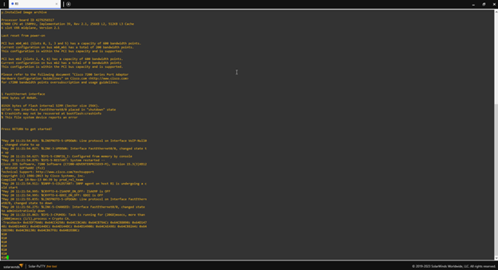

**R1:**

hostname R1

boot-start-marker

boot-end-marker

aqm-register-fnf

vrf definition left

address-family ipv4

exit-address-family

vrf definition right

address-family ipv4

exit-address-family

no aaa new-model

no ip icmp rate-limit unreachable

no ip domain lookup

ip cef

no ipv6 cef

multilink bundle-name authenticated

redundancy

ip tcp synwait-time 5

interface Ethernet0/0

no ip address

shutdown

duplex auto

interface GigabitEthernet0/0

no shutdown

vrf forwarding left

ip address 10.0.1.1 255.255.255.0

duplex full

speed 1000

media-type gbic

negotiation auto

interface GigabitEthernet1/0

no shutdown

vrf forwarding right

ip address 10.0.1.1 255.255.255.0

negotiation auto

interface GigabitEthernet2/0

no shutdown

vrf forwarding left

ip address 10.0.2.1 255.255.255.0

negotiation auto

interface GigabitEthernet3/0

no shutdown

vrf forwarding right

ip address 10.0.2.1 255.255.255.0

negotiation auto

router ospf 1 vrf left

router-id 1.1.1.1

network 10.0.1.0 0.0.0.255 area 0

network 10.0.2.0 0.0.0.255 area 0

router ospf 10 vrf right

router-id 1.1.1.0

network 10.0.1.0 0.0.0.255 area 0

network 10.0.2.0 0.0.0.255 area 0

ip forward-protocol nd

no ip http server

no ip http secure-server

no cdp log mismatch duplex

control-plane

mgcp behavior rsip-range tgcp-only

mgcp behavior comedia-role none

mgcp behavior comedia-check-media-src disable

mgcp behavior comedia-sdp-force disable

mgcp profile default

gatekeeper

shutdown

line con 0

exec-timeout 0 0

privilege level 15

logging synchronous

stopbits 1

line aux 0

exec-timeout 0 0

privilege level 15

logging synchronous

stopbits 1

line vty 0 4

login

transport input all

end

**R2:**

hostname R2

boot-start-marker

boot-end-marker

aqm-register-fnf

vrf definition left

address-family ipv4

exit-address-family

vrf definition right

address-family ipv4

exit-address-family

no aaa new-model

no ip icmp rate-limit unreachable

no ip domain lookup

ip cef

no ipv6 cef

multilink bundle-name authenticated

redundancy

ip tcp synwait-time 5

interface Ethernet0/0

no ip address

shutdown

duplex auto

interface GigabitEthernet0/0

vrf forwarding left

ip address 10.0.3.2 255.255.255.0

duplex full

speed 1000

media-type gbic

negotiation auto

interface GigabitEthernet1/0

vrf forwarding right

ip address 10.0.3.2 255.255.255.0

negotiation auto

interface GigabitEthernet2/0

vrf forwarding left

ip address 10.0.2.2 255.255.255.0

negotiation auto

interface GigabitEthernet3/0

vrf forwarding right

ip address 10.0.2.2 255.255.255.0

negotiation auto

router ospf 1 vrf left

router-id 2.2.2.2

network 10.0.2.0 0.0.0.255 area 0

network 10.0.3.0 0.0.0.255 area 0

router ospf 10 vrf right

router-id 2.2.2.0

network 10.0.2.0 0.0.0.255 area 0

network 10.0.3.0 0.0.0.255 area 0

ip forward-protocol nd

no ip http server

no ip http secure-server

no cdp log mismatch duplex

control-plane

mgcp behavior rsip-range tgcp-only

mgcp behavior comedia-role none

mgcp behavior comedia-check-media-src disable

mgcp behavior comedia-sdp-force disable

mgcp profile default

gatekeeper

shutdown

line con 0

exec-timeout 0 0

privilege level 15

logging synchronous

stopbits 1

line aux 0

exec-timeout 0 0

privilege level 15

logging synchronous

stopbits 1

line vty 0 4

login

transport input all

end

**R3:**

hostname R3

boot-start-marker

boot-end-marker

aqm-register-fnf

vrf definition left

address-family ipv4

exit-address-family

vrf definition right

address-family ipv4

exit-address-family

no aaa new-model

no ip icmp rate-limit unreachable

no ip domain lookup

ip cef

no ipv6 cef

multilink bundle-name authenticated

redundancy

ip tcp synwait-time 5

interface Ethernet0/0

no ip address

shutdown

duplex auto

interface GigabitEthernet0/0

no shutdown

vrf forwarding left

ip address 10.0.3.3 255.255.255.0

duplex full

speed 1000

media-type gbic

negotiation auto

interface GigabitEthernet1/0

no shutdown

vrf forwarding right

ip address 10.0.3.3 255.255.255.0

negotiation auto

interface GigabitEthernet2/0

no shutdown

vrf forwarding left

ip address 10.0.4.3 255.255.255.0

negotiation auto

interface GigabitEthernet3/0

no shutdown

vrf forwarding right

ip address 10.0.4.3 255.255.255.0

negotiation auto

router ospf 1 vrf left

router-id 3.3.3.3

network 10.0.4.0 0.0.0.255 area 0

network 10.0.3.0 0.0.0.255 area 0

router ospf 10 vrf right

router-id 3.3.3.0

network 10.0.4.0 0.0.0.255 area 0

network 10.0.3.0 0.0.0.255 area 0

ip forward-protocol nd

no ip http server

no ip http secure-server

no cdp log mismatch duplex

control-plane

mgcp behavior rsip-range tgcp-only

mgcp behavior comedia-role none

mgcp behavior comedia-check-media-src disable

mgcp behavior comedia-sdp-force disable

mgcp profile default

gatekeeper

shutdown

line con 0

exec-timeout 0 0

privilege level 15

logging synchronous

stopbits 1

line aux 0

exec-timeout 0 0

privilege level 15

logging synchronous

stopbits 1

line vty 0 4

login

transport input all

end

**R4:**

hostname R4

boot-start-marker

boot-end-marker

aqm-register-fnf

vrf definition left

address-family ipv4

exit-address-family

vrf definition right

address-family ipv4

exit-address-family

no aaa new-model

no ip icmp rate-limit unreachable

no ip domain lookup

ip cef

no ipv6 cef

multilink bundle-name authenticated

redundancy

ip tcp synwait-time 5

interface Ethernet0/0

no ip address

shutdown

duplex auto

interface GigabitEthernet0/0

no shutdown

vrf forwarding left

ip address 10.0.5.4 255.255.255.0

duplex full

speed 1000

media-type gbic

negotiation auto

interface GigabitEthernet1/0

no shutdown

vrf forwarding right

ip address 10.0.5.4 255.255.255.0

negotiation auto

interface GigabitEthernet2/0

no shutdown

vrf forwarding left

ip address 10.0.4.4 255.255.255.0

negotiation auto

interface GigabitEthernet3/0

no shutdown

vrf forwarding right

ip address 10.0.4.4 255.255.255.0

negotiation auto

router ospf 1 vrf left

router-id 4.4.4.4

network 10.0.4.0 0.0.0.255 area 0

network 10.0.5.0 0.0.0.255 area 0

router ospf 10 vrf right

router-id 4.4.4.0

network 10.0.4.0 0.0.0.255 area 0

network 10.0.5.0 0.0.0.255 area 0

ip forward-protocol nd

no ip http server

no ip http secure-server

no cdp log mismatch duplex

control-plane

mgcp behavior rsip-range tgcp-only

mgcp behavior comedia-role none

mgcp behavior comedia-check-media-src disable

mgcp behavior comedia-sdp-force disable

mgcp profile default

gatekeeper

shutdown

line con 0

exec-timeout 0 0

privilege level 15

logging synchronous

stopbits 1

line aux 0

exec-timeout 0 0

privilege level 15

logging synchronous

stopbits 1

line vty 0 4

login

transport input all

end

**Traceroute and Routing Tables:**

**Routing Tables:**

**PC1:**

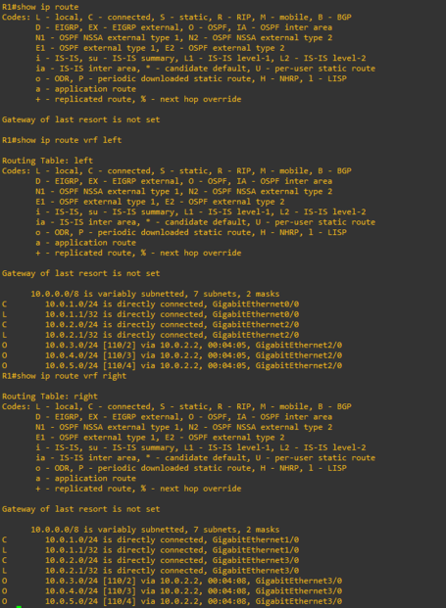

**PC2:**

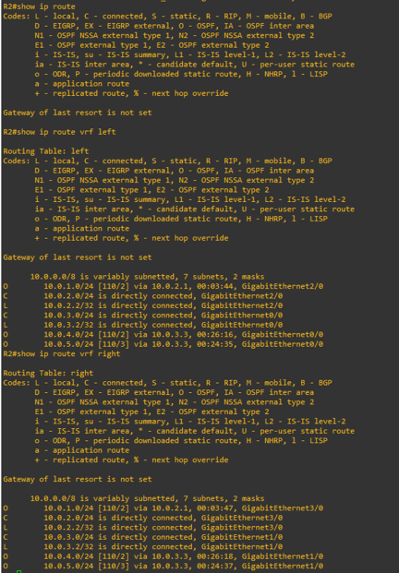

**PC3:**

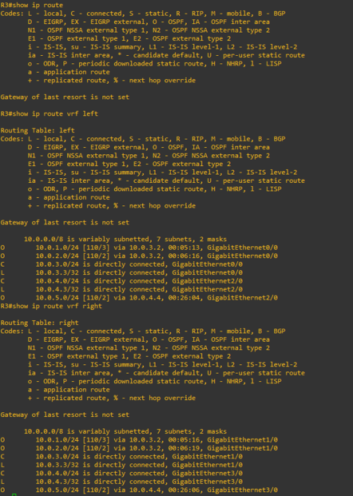

**PC4:**

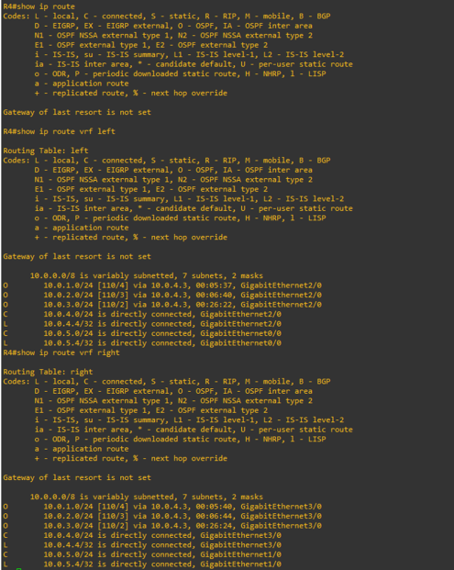

**Traceroute:**

**PC1 to PC3:**

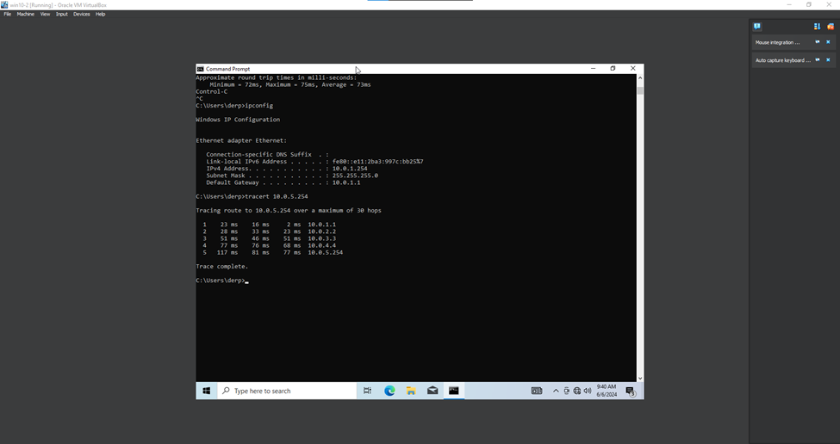

**PC2 to PC4:**

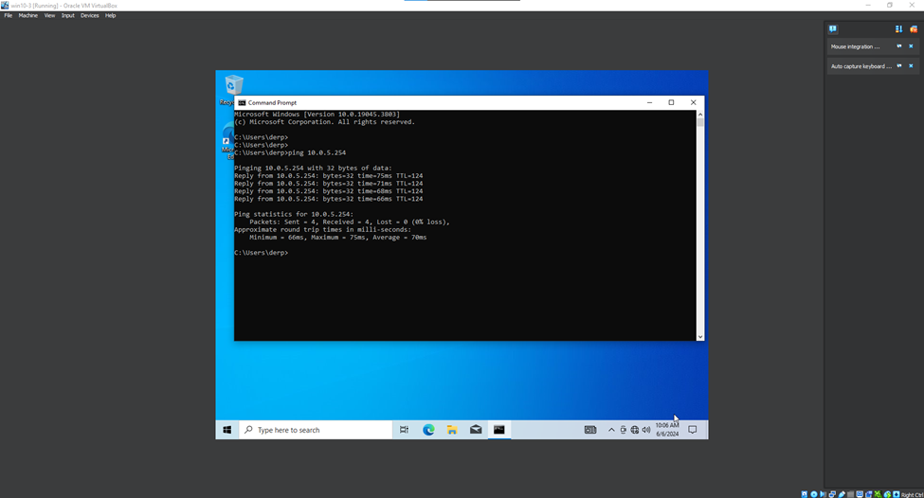

**Problems:**

1. **Didn’t Save GNS3 Configs**

Initially, we didn’t realize that GNS3 did not autosave router configs, and after we had finished our lab and come back the next day, our entire network topology configuration had been wiped.

1. **VMware VMnet interfaces**

We started off using GNS3 with VMware, but were unaware that GNS3 configuration of VMware interfaces required us to setup the VMnet settings in VMware. Due to unfamiliarity with this software, we decided instead to use VirtualBox in order to virtualize our Windows machines.

**Conclusion:**

Overall, this lab served as a thorough introduction to what VRF is and how to configure it. Furthermore, we learned how to use network virtualization software as well, utilizing GNS3 to create a virtual network. We were also able to review some network design and implementation basics, such as subnetting and topology configuration.

VRF Signoff Sheet

Ryan Chen, P3-4 Cisco CCNP, Mr. Mason

